***Chemistry notes:***

***Paper 1 – Required Practical’s:***

**Practical 1 - Making Soluble Salts:**

**Copper Sulfate, (CuSO4)**

* A salt contains a positive ion, in this case it is Cu2+, and this can come from:
  + Metal – Copper
  + Metal Oxide – Copper Oxide
  + Metal Hydroxide – Copper Hydroxide
  + Metal Carbonate – Copper Carbonate
* A salt also contains a Negative ion, in this case it is SO42-, this comes from:
  + The acid – Sulfuric acid

**Method:**

1. Place a fixed volume of dilute sulfuric acid into the beaker
   * This is the limiting reactant
   * This means there should be no acid left at the end
2. Gently heat until it is almost boiling
3. Using the spatula, add small amounts of copper oxide to the acid
   * Stir this with a glass rod
   * The copper oxide will react and seem to disappear
   * The solution will change colour to clear blue
4. Keep adding copper oxide until It stops reacting
   * The reaction will stop as all the acid has reacted
5. Filter the solution to remove the excess copper oxide
   * Using a filter funnel and filter paper
6. Put the filtered solution into an evaporating basin
7. Place this over a boiling beaker of water
8. Do this until there is half of the solution left
   * Then, leave to cool for 24 hours
9. Lastly, scrape the crystals onto a paper towel and pat them dry gently

**Practical 2 - Carrying out a Titration:**

A titration is the neutralising of an alkali in order to find out the amount of acid needed to do so

**Method:**

1. Use a pipette to transfer 25cm3 of sodium hydroxide solution (alkali) into a conical flask
2. Add 5 drops of an indicator
3. Then place a white tile underneath
4. Fill a burette with Sulfuric Acid
5. Add the acid from the burette into the alkali until the solution is neutral
   1. Once you start to see a colour change, add acid drop by drop until the solution is neutral
   2. Make sure you swirl the solution to make sure the acid and alkali mix
6. Read the volume of acid added from the burette

**Practical 3: Electrolysis of aqueous solutions:**

* In aqueous solutions water turns into H+ ions and OH- ions.
* 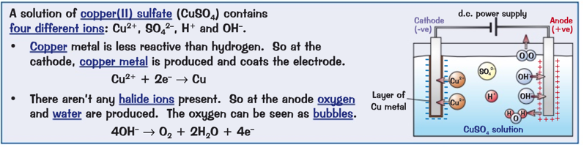At the cathode
  + If H+ ions and metal ions are present
    - If the metal is more reactive than hydrogen:
      * Hydrogen gas will be produced
    - Otherwise:
      * A solid layer of the pure metal will be produced
* At the anode
  + 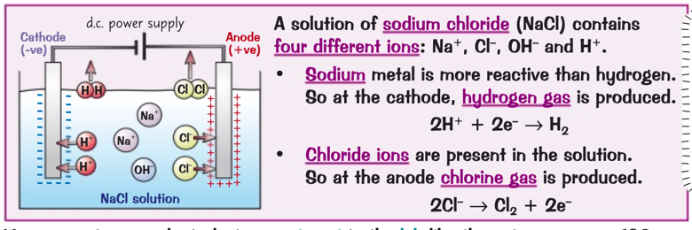If OH- and halide ions are present
    - Molecules of chlorine, bromine or iodine will be formed
  + If no halide ions are present
    - The OH- ions are discharged and oxygen is formed

**Practical 4: Temperature Changes:**

* A close up of text on a white background

  Description automatically generatedThe variables that affect temperature changes in chemical reactions
  + Reactions are exothermic or endothermic

**Method:**

1. Measure out 30 cm3 of dilute hydrochloric acid
   1. Put this into a polystyrene cup
      1. Put the polystyrene cup into a beaker to stop it from falling over
      2. Place insulating material around the cup
2. Measure the temperature of the acid
   1. Record the value in a table
3. Measure out 5 cm3 of sodium hydroxide
   1. Place this into the polystyrene cup
4. Put a lid with a hole in the middle on top of the cup
   1. Place a thermometer in
      1. Use it to gently stir
5. Measure the temperature using the thermometer
   1. Record the highest temperature reached
6. Repeat steps 1-5 but adding an extra 5 cm3 of sodium hydroxide each time
   1. Do this until you reach 40 cm3
7. Repeat steps 1-6
8. Calculate a mean value using the results
9. Draw a graph of temperature-time